Introduction
Supervised learning is the most prevalent form of machine learning and is employed widely across industry and academia. Although there are many different models in existence, they all seek to obtain the same result: a mapping (f) from the input space (henceforth to as x) to the output space (henceforth referred to as y) that minimizes some form of loss [1]. It is reasonable to assume that for every dataset there exists some function f* which will result in the lowest possible loss, and is therefor the best mapping from x to y [1]. In practice, obtaining f* is impossible as it would be necessary to search the entire possible space of mappings from x to y. As such, it is commonplace to restrict the search space to a given model class (SVM, regression, XGBoost, etc) and then attempt to learn the optimal parameters for that model type based on the data through some optimization algorithm [1]. It is again reasonable to assume that for a given model class, there is some set of parameters which results in the lowest possible loss within that model class. This function is referred to as f▲, and by definition loss(f*) ≤ loss(f▲). It is important to note that when training a model in practice, the resultant mapping f● will rarely be equal to f▲, and is extremely unlikely to ever equal f* [1].
The formulation above highlights two of the three sources of error in supervised learning, with the third being noise [1]. The first one is referred to as approximation error, and is a result of the difference between the selected model type and the form of the optimal mapping f*. The second one is referred to as estimation error, and is a result of the difference between the trained model and the model with the best possible parameters for the selected model class (f▲) [1]. When a data scientist is going through the process of model selection, they are attempting to minimize the approximation error, whereas when they are training a given model, they are attempting to reduce the estimation error [1]. While the process of model selection is manageable in the case of classical machine learning using techniques such as stochastic holdout [1], it is incredibly difficult for neural networks. This is because neural networks are not a class of model per say, but are more of a superclass where each neural architecture is like it’s own model class. As such, obtaining a suitable neural architecture with a technique like stochastic holdout would be borderline impossible. For the most complex problem sets, the process of generating a performant neural architecture requires teams of scientists and usually results in models that have billions of parameters [2].
A significant amount research has has been conducted into techniques that can automatically determine a suitable neural architecture for a given problem set. The idea is to use the data to estimate both the architecture and the parameters, thereby reducing both the approximation and the estimation errors simultaneously. These approaches alleviate the need for model selection and ideally enable the resultant model to more closely approximate the optimal mapping f*. This field of research is broadly referred to as as neural architecture search, and has several lines of effort. One of the more successful ones is known as neuroevolution, a technique which takes inspiration from evolutionary biology and uses genetic algorithms to evolve an appropriate architecture. The NeuroEvolution of Augmenting Topologies (NEAT) [3] algorithm has been demonstrated to evolve well – performing artificial neural networks, and the algorithm has been extended to convolutional [4] and recurrent [5] neural networks. The latter is referred to as Evolutionary eXploration of Augmented Memory Models (EXAMM), and the extension of this algorithm is the topic of this paper.

Problem Statement
EXAMM is an extension of the NEAT algorithm that is able to generate complex recurrent neural architectures for different time series datasets. At it’s core, there is a master process that maintains the current population of Recurrent Neural Network (RNN) genomes. This population is spread out across several islands, with each island containing an identical number of genomes. At each timestep, EXAMM selects an island in a round – robin manner, and then randomly selects a genome from that island to evolve. It applies one of twelve genetic operations to that genome and trains it for a given number of back propagations on one of the worker nodes. The possible genetic operations along with descriptions and associated probabilities are listed in Table 1. Once the genome has been trained, EXAMM attempts to re – insert it into the island from which it was initially picked. If the test set performance, or fitness, of the newly trained genome is superior to that of the worst genome in the selected island, the worst genome is replaced with the new one. This process continues until the maximum number of allowed genomes is generated [5]. Certain operations will result in the insertion of new recurrent edges into the architecture of a given genome. The depths of these recurrent edges are drawn from a uniform probability distribution, which returns values between the minimum and maximum recurrent depths as set by the programmer prior to running the algorithm.
Operation | Description | Rate
Clone | Creates a copy of the parent genome, initializing it to the same weights. Allows it to continue training unaltered. | 0.07
Add Edge | Adds an edge between two nodes if one does not already exist. | 0.07
Add Recurrent Edge | Adds a recurrent edge between two nodes if one does not already exist. Recurrent edge depths are drawn from a uniform distribution. | 0.07
Enable Edge | Selects a random disabled edge (regular or recurrent) and enables it. Only occurs if disabled edges are present. | 0.07
Disable Edge | Selects a random enabled edge (regular or recurrent) and disables it. | 0.07
Add Node | Selects a random depth between the input and output layers and inserts a node of the selected type. Node types are drawn from a uniform distribution, and can be a simple neuron or a complex memory cell such as LSTM. | 0.07
Enable Node | Selects a random disabled node and enables it. Only occurs if disabled nodes are present. | 0.07
Disable Node | Selects a random enabled node and disables it. | 0.07
Split Node | Selects a random hidden node and splits it. The node is disabled using the “Disable Node” operation and two new nodes are created at the same depth. | 0.07
Merge Node | Selects two random hidden nodes at random and combines them. The nodes are disabled using the “Disable Node” operation and a new node is created at the average depth of the two parent nodes. | 0.07
Crossover | Selects another genome from the same island as the candidate and performs a crossover with the two genomes. This generates a child genome using all reachable nodes and edges from the two parents. | 0.20
Island Crossover | Selects the best genome from all other islands and preforms a crossover between it and the selected genome. This generates a child genome using all reachable nodes and edges from the two parents. | 0.10
Table 1: Genetic Operations in EXAMM
It is not unreasonable to assume that certain genetic operations are more likely to result in well – performing genomes, and that the preferred operations will change over time as the population evolves. As such, introducing a component which is able to adjust the associated rates as EXAMM is generating new networks may improve the performance of the algorithm.
Other processes within EXAMM that may benefit from rate adjustment include island selection and recurrent depth selection. Treating all islands equally by cycling through them in a round-robin manner may not be the optimal approach. The populations of different islands tend to be heterogeneous with some islands having better-performing genomes than others. Selecting the better islands more frequently has the potential to improve the performance of EXAMM. Furthermore, it is possible that not all recurrent edge depths are pertinent to a given dataset, and so dynamically adjusting the rates associated with different depths could also improve the performance of the algorithm.
This paper presents the results obtained from extending EXAMM with Finite Action-Set Learning Automata (FALA), which allows for the dynamic adjustment of the rates associated with the selection of different genetic operations, islands, and recurrent depths. The inclusion of this component results in a significant performance improvement and provides further insight into the EXAMM algorithm.

Finite Action-set Learning Automata
FALA is a reinforcement learning algorithm which evolves a vector of discrete probabilities associated with a set of actions. This approach has shown promise in the field of robotics engineering, where it has been used for behavioral design [12] and controller parameter tuning [13] [14] [15]. Like all reinforcement learning approaches, FALA requires an agent, an environment, and an interpreter [6]. The agent selects an action to perform according to some policy, and executes the selected action against the environment. The agent can have multiple states and taking a certain action may or may not result in a state transition. If an agent does have multiple states then the policy by which the agent selects an action will be dependent on the agent’s current state. The result of taking a given action is analyzed by the interpreter, which generates a reinforcement signal to the agent so that it may update it’s policy, and informs the agent if a state transition has occurred. This process is visualized in Figure 1.
A FALA process for a single – state agent can be described by the following quadruple:
Γ = (a, p(t), r, τ)
In the formulation above, the four components represent the following [7]:
- A finite set of possible actions, generally referred to as the action set. For the purpose of this paper it will be defined as ɑ = {ɑ₁, ɑ₂, … , ɑ_{n}}. The action selected at time point t is defined as ɑ(t).
- The probabilities associated with each action at time point t, which is defined as a probability vector p(t) = (p_{t}(ɑ₁), p_{t}(ɑ₂), … , p_{t}(ɑ_{n})). This vector is initialized at time step 0 to the starting probability values. It can be thought of as the policy by which the agent selects an action.
- A reinforcement function r(t) which will observe the results of the action taken at time t and generate a reinforcement signal r_{t}. It can be thought of as the interpreter in the context of figure 1.
- A function τ which will take the reinforcement signal generated by the reinforcement function and use it to update the action probabilities, such that p(t+1) = τ(ɑ(t), p(t), r_{t}).
At time step t, the agent selects an action ɑ(t) in accordance with the probability vector p(t), and carries out that action against the environment. The result of this action is interpreted by the reinforcement function r(t) and an appropriate reinforcement signal r_{t} is generated and passed to the agent, which updates it’s probability vector through τ. Typically this is done by multiplying the reinforcement signal by some multiplier (often referred to as the learning rate), adding it to the appropriate probability, and then normalizing the probabilities so that they again add up to 1. The process repeats until the maximum number of iterations is reached or the action probabilities converge to a single value. In some cases the latter outcome is undesirable, and there are several techniques that can be used to prevent this from happening [8]. The most obvious approach is to enforce a minimum value for each action probability, which will de facto prevent convergence. Other techniques include negative reinforcement, rate-based reinforcement, and staged learning.
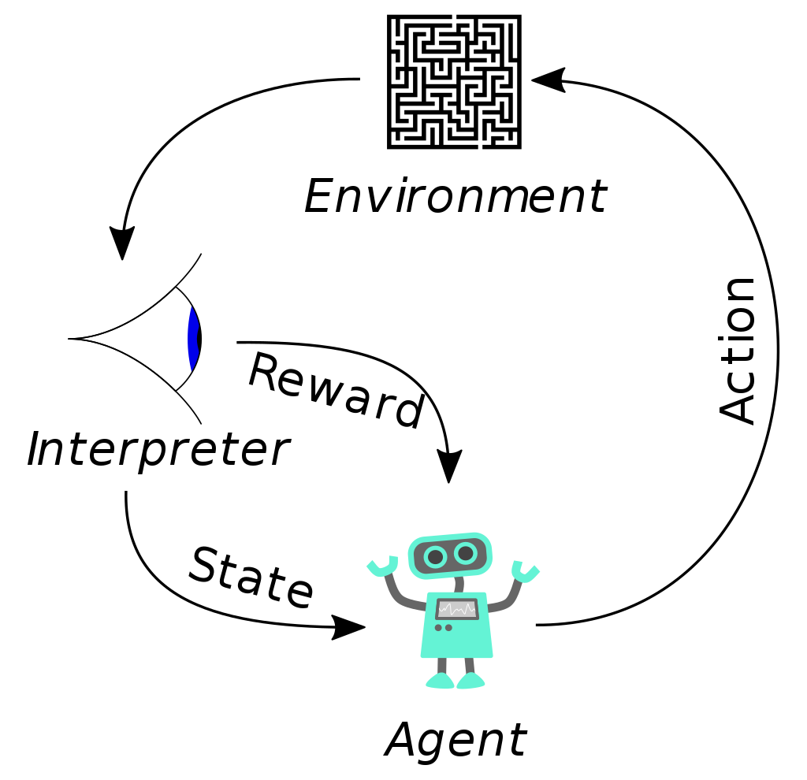

Figure 1: Reinforcement Learning

Action Probability Minimums
Enforcing rate minimums ensures that no action will be completely removed from play. The slack available to the learning algorithm is proportional to sum of the differences between the starting and minimum rates of all actions. The decision of where to set the rate minimums comes down to trial and error and is effectively a set of hyper-parameters that is set by the programmer.

Negative Reinforcement
Negative reinforcement is the punishment applied to actions that have undesirable outcomes and results in their probabilities being adjusted downwards. While it may be used at any point during the learning process, it is often applied only once an action probability exceeds a certain degradation threshold, which is generally set to be equal to or greater than the initial probability for a given action. The degradation thresholds associated with the elements in the probability vector are set by the programmer, and are another set of hyper-parameters that need to be tuned. Negative reinforcement, when applied selectively to rates exceeding their degradation thresholds, makes it very difficult for any given action probability to dominate the others.

Rate-Based Reinforcement
Rates-based reinforcement means scaling the reinforcement signal based on the current probability of the action being reinforced. The positive reinforcement for high action probabilities is scaled downwards and the positive reinforcement for low probabilities is scaled upwards. The opposite is true for negative reinforcement. This helps actions with lower probabilities learn rapidly and slows the learning of actions with higher probabilities. The reinforcement may be scaled either to the starting rate of an action or to the largest rate in the probability vector. This makes it progressively more difficult to learn as the probabilities for certain actions increase, and if used alongside negative reinforcement can significantly impede the learning of high probability actions.

Staged Learning
In staged learning, the FALA process is broken down into a number of stages. Each stage consists of a certain number of iterations, and after that number of iterations is reached a stage transition occurs. During a stage transition the action probabilities are reset to their initial values, thereby forgetting all the learning that took place in the previous stage. This allows the algorithm to learn from scratch, enabling it to adapt to a continuously changing environment. Optionally, the minimum values and the degradation thresholds for each action probability may be altered during a stage transition. This increases the slack afforded to the learning algorithm as it advances through the stages, and makes learning easier by applying negative reinforcement at increasingly higher thresholds.

A Game of FALA
A game of FALA refers to situations where at every timestep, an agent takes not one but several interdependent actions, meaning it is impossible to attribute the outcome to any single action [9]. The actions are chosen independently but due to the inherent interdependence, the choice of action from one process may effect the desirability of the others. Reinforcement is applied based on the cumulative result, where each FALA process has it’s own interpreter but the outcome being interpreted is identical across all learning processes. The algorithm reinforces desirable combinations of actions from all processes and not the most desirable actions in each process. Mathematically, a game of FALA is nothing more than a list of quadruples: Γ = (Γ¹, Γ², …, Γ^{n}), where n is the total number of concurrent FALA processes [10].

Algorithm
The complete FALA algorithm as described in this section can be formulated as follows:
iterations_in_stage = 0 //If staging
for t in 1..MAX_ITERATIONS:
- for each FALA process Γ^{i}:
  - ɑ^{i}(t) = select_action(ɑ^{i}, p^{i}(t))
  - Execute ɑ^{i}(t)
- for each FALA process Γ^{i}:
  - r_{t}^{i} = r^{i}(ɑ¹(t),…, ɑ^{n}(t)) //Potentially negative reinforcement
  - r_{t}^{i} = scale(r_{t}^{i}, p^{i}(t)) //Optional for rate-based scaling
  - p^{i}(t + 1) = τ(ɑ^{i}(t), p^{i}(t), r_{t}^{i}) //Enforce minimum rates
- if iterations_in_stage == ITERATIONS_PER_STAGE: //If staging
  - iterations_in_stage = 0
  - for each FALA process Γ^{i}:
    - p^{i}(t + 1) = p(0)
    - adjust(min_rates^{i}, degradation_thresholds^{i}) //Optional

Applying FALA to EXAMM
As EXAMM evolves new networks it maintains a population of candidate genomes spread across a certain number of islands, with each island maintaining a given number of genomes. These two parameters are used to calculate an appropriate number of iterations per stage, which is a multiple of the product of the number of islands and the number of genomes per island. The performance of a newly generated genome is evaluated when EXAMM attempts to insert it back into the island it was picked from, and a reinforcement signal is calculated based on two factors: the loss on the test set and the ranking of the genome within the island. Positive reinforcement is only applied if the ranking is non – negative, which indicates that the genome was successfully inserted. If the genome was not inserted then there is a potential for negative reinforcement, which will be applied to the operation that generated the genome if the rate associated with that operation exceeds it’s degradation threshold. The rates of all processes are then updated based on the reinforcement signal, while ensuring no rate drops below it’s minimum threshold. Stage transitions occur as necessary and the associated operations take place. EXAMM needs to be given some time to warm up to a point where rate adjustment is viable, so no learning takes place during the first stage. The starting action probabilities, minimum rates, degradation thresholds, and reinforcement functions are determined independently for each FALA process. In all FALA processes, the probability vector is updated as follows:
- Multiply the reinforcement signal by some learning rate
- Add the result to the probability associated with the action being reinforced
- Normalize the probability vector, ensuring that no rate falls below it’s minimum threshold

Genetic Operation Rates
The action set and initial probability vector p(0) are already provided in table 1. The positive reinforcement signal is calculated as a weighted average of it’s ranking and it’s test set performance, whereas the negative reinforcement signal is a fixed constant.

Island Selection Rates
At each iteration, EXAMM selects an island in a round – robin manner, choosing a genome from the island at random and evolving it. This is modified so that after the first stage is complete, EXAMM selects an island according to an evolving distribution. The action set is the collection of islands and the probability vector stores the probabilities associated with selecting each island. The probability vector is initialized uniformly with each island receiving a starting probability equal to 1/num_islands. The reinforcement signal has an additional component, granting a small reward to the island with the best genome each iteration.

Recurrent Depth Rates
The depth of newly inserted recurrent edges is drawn from a uniform distribution, with values ranging between the minimum and maximum recurrent depths set by the programmer. Newly created recurrent edges are marked so that the learning process can identify which recurrent edges contributed to the delta in performance. After an edge has been examined it is unmarked for learning so that it’s depth is not reinforced in future iterations. The action set is the list of all possible recurrent depths and the initial probabilities are initialized uniformly to 1/num_depths for each depth. Some operations may result in the addition of multiple recurrent edges in a single iteration. The reinforcement function accounts for this by dividing the total reinforcement by the number of new recurrent edges and reinforcing each depth accordingly.

Exploration vs Exploitation
The exploration vs exploitation dilemma is common in machine learning, and is certainly present in this context. When it comes to FALA, exploration generally assumes slower learning to allow the algorithm to explore various combinations without getting too entrenched in initial positive results. On the other hand, exploitation assumes faster learning where actions that initially lead to good results are strongly reinforced. It is possible to play these concepts off of one another: one option is to have fast learning with generous slack but to frequently reset the rates by having short stages. This allows the algorithm to rapidly increase the rates for actions that are doing well while the frequent resets during stage transitions force the algorithm to re – discover desirable actions. Another option is to have slower learning and longer stages. This approach takes longer to learn but it is more robust to outlier situations where an action which is not generally desirable results is reinforced due to some low – probability event. This tradeoff is controlled by adjusting the various FALA hyper-parameters.

Experimental Approach
The EXAMM algorithm was run in three different configurations, ten times per configuration. The results of these runs were compared to determine whether FALA added anything of value and if so which combination of hyper-parameters resulted in the best RNNs being generated. The following configurations were considered:
- Base EXAMM to provide a point of comparison
- A slower learning approach with fewer stages and tighter minimums rates and degradation thresholds
- A faster learning approach with a larger number of short stages but with looser minimum rates and degradation thresholds
Each run was configured to use five islands each with a population of five genomes. The minimum recurrent depth was set to 1 and the maximum recurrent depth was set to 10. The runs were set to terminate when 2000 genomes were generated. The FALA hyper-parameter settings for the last two configurations are summarized in table 2. The first configuration is not included since there are no FALA hyper-parameters in base EXAMM.
Approach | Learning Process | Stages | Learning Rates | Minimum Probabilities | Degradation Thresholds | Negative Reinforcement
Slower Learning | Islands | 4 | 0.005 | Start at 0.2, multiplied by 0.965 every stage | Start at 0.2, increased by 0.02 every stage | Start at 0.3, increased by 0.05 every stage, scaled to degradation threshold
Slower Learning | Genetic | Unstaged | 0.0005 | Mutation: 0.055,  Crossover: 0.17,  Island Cross: 0.09 | Mutation: 0.075,  Crossover: 0.21,  Island Cross: 0.105 | 0.5, scaled to degradation threshold
Slower Learning | Depths | Unstaged | 0.0005 | 0.08 | 0.12 | 0.5
Faster Learning | Islands | 10 | 0.007 | Start at 0.2, decrease by 0.00625 each stage transition | Start at 0.2, increase by 0.00625 each stage transition | 0.5, scaled to degradation threshold
Faster Learning | Genetic | 10 | 0.002 | Mutation: 0.04,  Crossover: 0.14,  Island Cross: 0.06 | Mutation: 0.1,  Crossover: 0.26,  Island Cross: 0.14 | 1.0, scaled to degradation threshold
Faster Learning | Depths | 10 | 0.002 | 0.06 | 0.12 | 1.0

Table 2: Run Configuration Settings
The best genome from each run was recorded and the results were compared using the Mann-Whitney U to determine whether the difference between the different configurations is statistically significant. The evolution of the various action probabilities was recorded for further analysis. All runs are carried out using the coal – fired powerplant dataset. The dataset is a collection of minute – by – minute readings taken from 12 sensors in a coal powerplant burner over 120 days. Readings from sensors 1 to 11 are used as predictor variables and the reading from sensor 12 (main flame intensity) is the response.

Results
The experimental results are presented in table 3 and visualized in figure 2. The comparisons of different populations using the Mann-Whitney U test are presented in table 4. These results demonstrate that the extension of EXAMM with FALA was successful in improving the overall performance. It is clear that means and medians of the slower and faster learning configurations are better than those of the base algorithm. The result of the Mann-Whitney U test between the base configuration and slower learning configuration is significant at p = 0.05. The p – value of the Mann-Whitney U test between the base configuration and the faster learning configuration is relatively low but not considered significant at any commonly – accepted threshold.
 | Base EXAMM | Slower Learning | Faster Learning
Run 1 | 0.001418 | 0.0013 | 0.001778
Run 2 | 0.001584 | 0.001291 | 0.00119
Run 3 | 0.00178 | 0.001629 | 0.001228
Run 4 | 0.001472 | 0.001221 | 0.00127
Run 5 | 0.001492 | 0.001168 | 0.001436
Run 6 | 0.001342 | 0.00138 | 0.001271
Run 7 | 0.001254 | 0.000952 | 0.001356
Run 8 | 0.001456 | 0.001374 | 0.001526
Run 9 | 0.001966 | 0.001399 | 0.001218
Run 10 | 0.0012 | 0.001134 | 0.001536
- | - | - | -
Mean | 0.0014964 | 0.0012848 | 0.0013809
Med | 0.001464 | 0.0012955 | 0.0013135
Min | 0.0012 | 0.000952 | 0.00119
Max | 0.001966 | 0.001629 | 0.001778
Var | 5.4163*10⁻⁸ | 3.3335*10⁻⁸ | 3.5243*10⁻⁸
Table 3: Experimental Results
The slower and faster learning approaches have comparable medians, but as seen in figure 2, the faster learning approach has an upwards skew which implies that it has more poorly – performing runs than the slower learning approach. This could be because the faster learning approach immediately reinforces the first good results, and even with periodic resets at stage transitions it may be too greedy. Another explanation for this could be chance: the p – value for the Mann-Whitney U test between the two FALA configurations is relatively high which suggests that there may not be a difference between the two populations. The number of runs for each configuration is relatively small which would allow for this kind of randomness. More investigation will be required to determine whether there is a difference between the two FALA approaches.
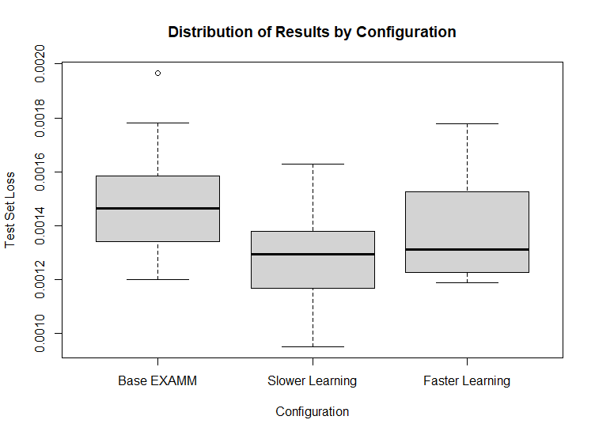
Figure 2: Experimental Result Distributions by Configuration

Population 1 | Population 2 | Mann-Whitney U
Base EXAMM | Slower Learning | 0.03546
Base EXAMM | Faster Learning | 0.2799
Slower Learning | Faster Learning | 0.4359
Table 4: Mann-Whiteny U Test Results
Assuming that the slower learning approach is indeed superior to the faster learning approach, it would appear that in the context of EXAMM, exploration is preferred to exploitation. This could be because exploitation is difficult in such a dynamic environment, where the population of genomes is constantly being renewed. Another explanation could be that favoring any one selection too heavily is detrimental for the evolution of new genomes, implying that a successful genome is evolved when all selections are at used at least somewhat evenly. To better understand which selections were more successful, we can analyze the plots of the different rates over time from different runs. Figures 3 and 4 shows the evolution of genetic operation rates, island rates, and recurrent depth rates for the best runs in both the slower and faster learning approaches respectively. Figures 5 and 6 show the same graphs but for an average run from each configuration, and figures 7 and 8 show the same graphs but for the worst run from each configuration.
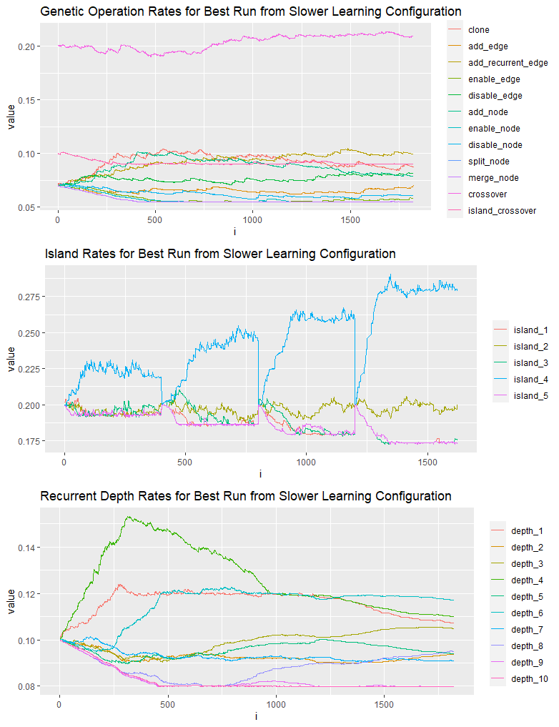
Figure 3: Evolution of Rates from Best Run of Slower Learning Configuration

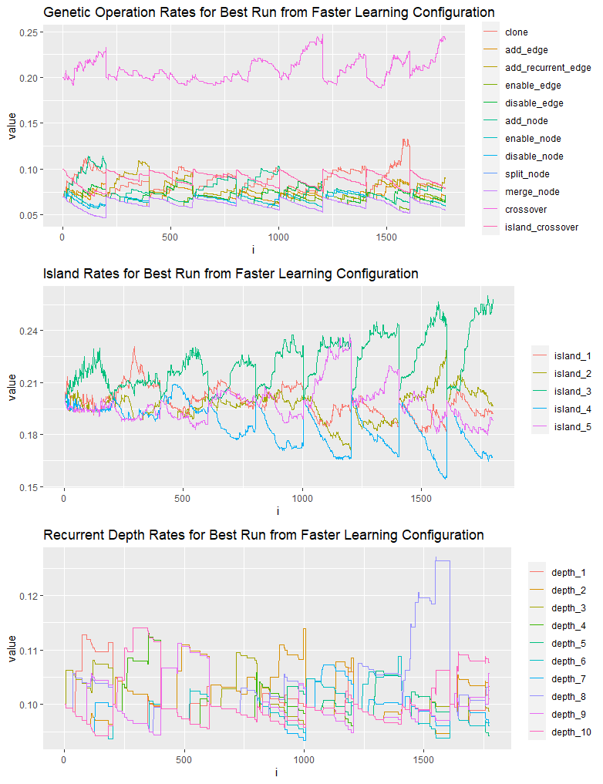
Figure 4: Evolution of Rates from Best Run of Faster Learning Configuration

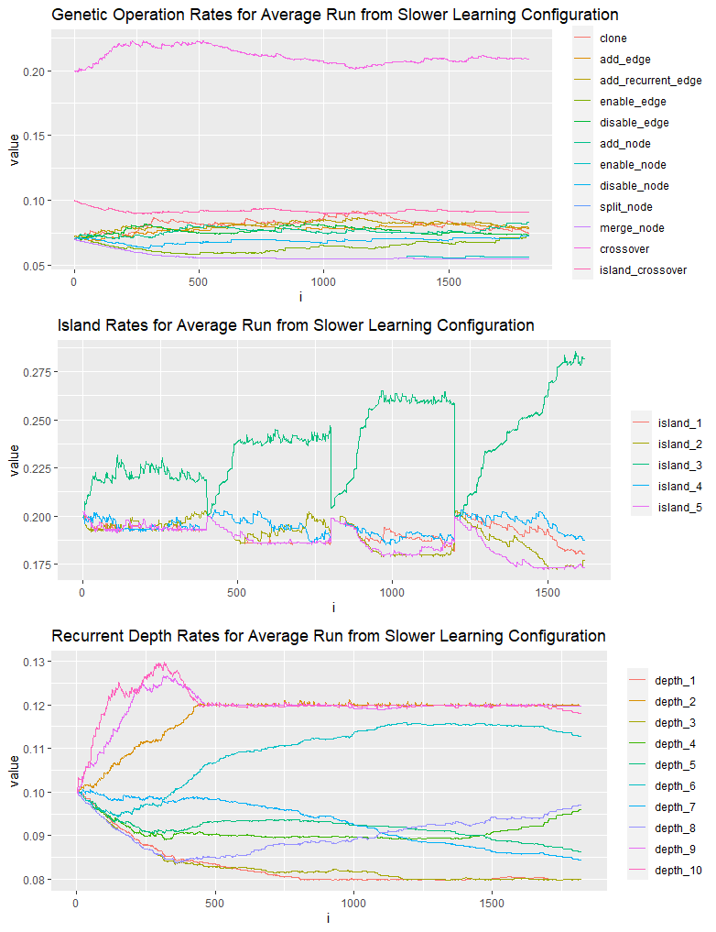
Figure 5: Evolution of Rates from Average Run of Slower Learning Configuration

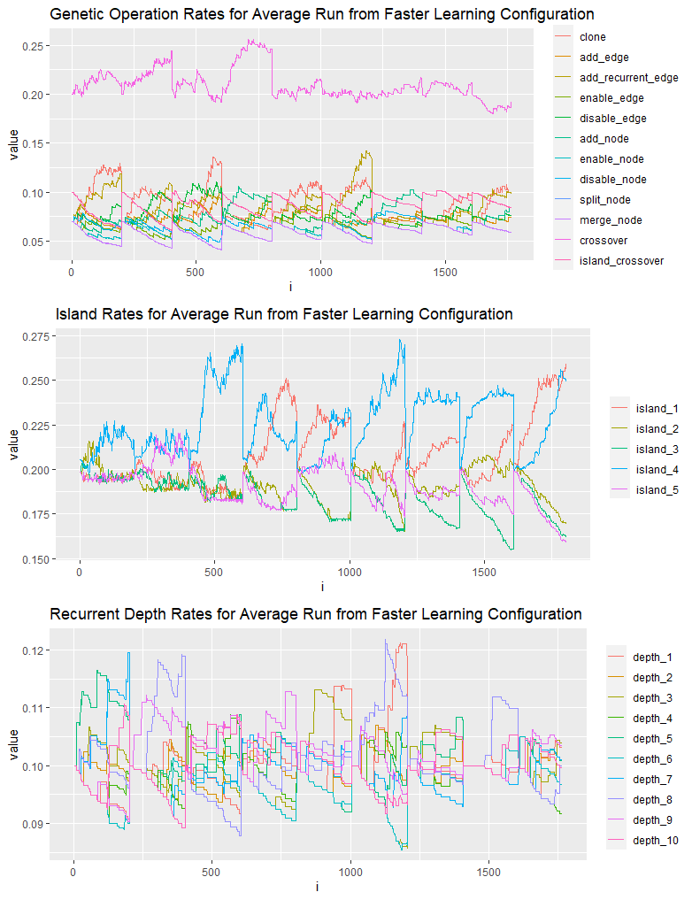
fFigure 6: Evolution of Rates from Average Run of Faster Learning Configuration

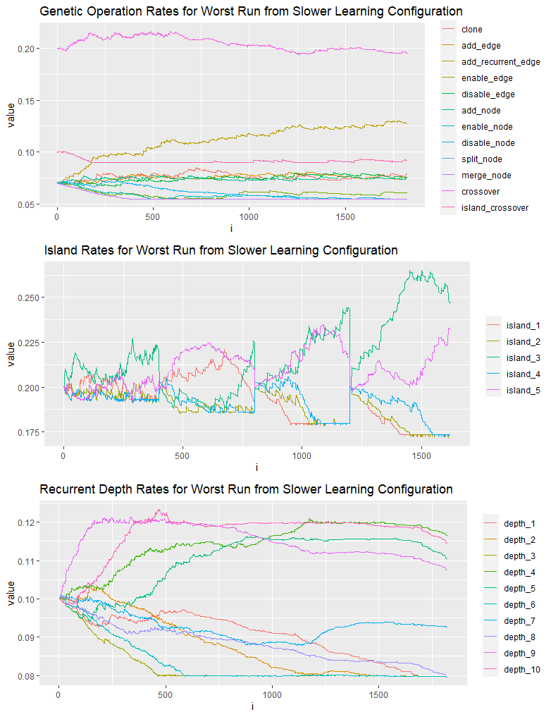
Figure 7: Evolution of Rates from Worst Run of Slower Learning Configuration

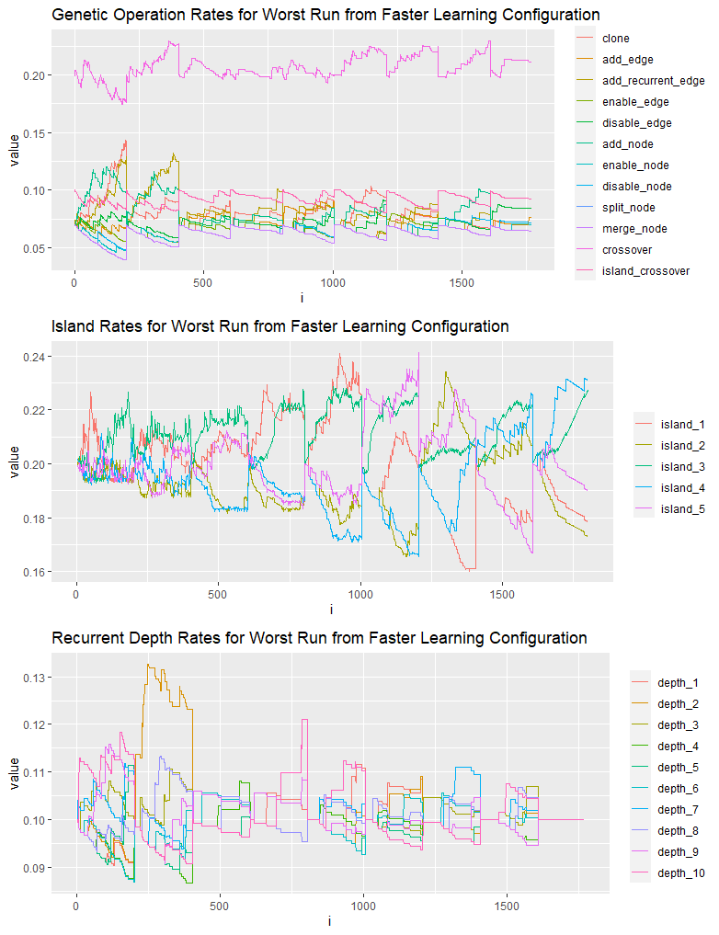
Figure 8: Evolution of Rates from Worst Run of Faster Learning Configuration

The difference between the slower and faster approaches is evident through the evolution of the genetic operation and recurrent depth rates. This provides a good visualization of the exploration vs exploitation tradeoff discussed in other sections of this paper. The evolution of the island selection rates is actually somewhat comparable, apart from the fact that one has 4 stages and the other has 10. This makes sense because their hyper-parameter configuration as outlined in table 2 is almost identical. It is interesting that for both of the worst runs, the island rate has trouble settling on a best island with many different islands being reinforced, whereas in the best runs the best island seems to be settled on relatively early on. A potential explanation for this is that the performance of a run is largely dependent on how well it starts. If the algorithm has a mediocre start there will be multiple islands with good but not amazing genomes which will compete with each other throughout the process, whereas if the algorithm has a good start there will likely be one or two islands with genomes that are substantially better than the other islands, and this is reflect in the rates of those islands being heavily reinforced.
Rate dynamics for genetic operations are better visualized in the faster configuration, where it is evident that there is no single operation that dominates after every single reset. That being said, there are operations which almost never see their rate increased, implying that they are much less likely than the others to result in good genomes being generated. The crossover operation seems to always do well, as do the clone, add recurrent edge, and add node operations. The add edge, disable edge, and island crossover operations also perform decently, whereas the remainder are almost never reinforced. Of the ones that are reinforced, the disable edge operation is most surprising, intuition would suggest that disabling edges would lower the complexity of the network and therefor result in worse performance. One potential explanation is that disabling edges acts as a form of regularization, which is really important in preventing overfitting.
The recurrent depth rates don’t seem to suggest anything too interesting and their evolution appears more as noise than anything else. The learning process for them does not appear to be useful although this is something that will need to be explored further. The assumption was that certain depths with resonate better with the dataset than others and would result in better performance, but this does not appear to be the case.

Conclusion
Reinforcement learning has been applied to a number of problem spaces outside of the robotics applications discussed earlier. Hyper-parameter tuning is an open problem and one that is very prevalent in machine learning. There have been several studies that applied variations of reinforcement learning to tune the hyper-parameters of a neural network [18] [19]. These are related to the work presented in this paper, but revolve around converging on a single set of hyper-parameters instead of continuously evolving the rates associated with some inner workings of an algorithm. Other studies have attempted to influence the behavior of evolutionary algorithms through Gaussian process fitness function models [20], and recently reinforcement learning has been applied to evolutionary algorithms [21] to improve their performance. That being said, to our knowledge there has been no work prior to this that has improved neuroevolutionary algorithms through reinforcement learning.
One avenue for further exploration would be to try different FALA learning configurations and to do so for a greater number of runs to collect more data. Another could be to try and apply other algorithms, such as continuous action reinforcement learning automata [16] or multi – armed bandit [17] to EXAMM. Future work could also include the addition of reinforcement learning to other neuroevolutionary algorithms, such as NEAT [3] and EXACT [4]. It would also be interesting to investigate why some EXAMM runs have really good starts and how to increase the probability of that occurring.
This work extended an existing neuroevolutionary algorithm, EXAMM, with a reinforcement learning algorithm in order to dynamically adjust the rates associated with different processes within EXAMM. The addition of reinforcement learning resulted in significantly better performance, especially with the slower learning configuration. The analysis of how the rates evolved has provided insight into which operations are more likely to result in well – performing genomes.

References
[1] https://www.ams.org/journals/notices/202002/rnoti-p155.pdf
[2] https://arxiv.org/pdf/2005.14165.pdf
[3] http://nn.cs.utexas.edu/downloads/papers/stanley.ec02.pdf
[4] https://arxiv.org/abs/1703.05422
[5] https://arxiv.org/abs/1902.02390
[6] https://www.jair.org/index.php/jair/article/view/10166
[7] https://ieeexplore.ieee.org/abstract/document/8369551
[8] https://qspace.library.queensu.ca/handle/1974/24245
[9] http://www.dklevine.com/archive/refs4481.pdf
[10] https://www.springer.com/gp/book/9781402076916
[11] https://onlinelibrary.wiley.com/doi/10.1002/acs.2882
[12] https://ieeexplore.ieee.org/document/7018006
[13] https://ieeexplore.ieee.org/document/7934801
[14] https://www.sciencedirect.com/science/article/pii/S240589631730770X
[15] https://ieeexplore.ieee.org/abstract/document/7934800
[16] https://ieeexplore.ieee.org/document/856947?arnumber=856947
[17] https://hal.inria.fr/file/index/docid/278542/filename/pap333s1-dacosta.pdf
[18] https://ieeexplore.ieee.org/abstract/document/8457698/figures#figures
[19] https://arxiv.org/abs/1906.11527
[20] https://ieeexplore.ieee.org/abstract/document/1424193
[21] https://www.sciencedirect.com/science/article/abs/pii/S095070512100099X

Selecting an appropriate neural architecture for a given dataset is an open problem in machine learning, and this is especially true for time series data. Recurrent neural networks need to capture the underlying relationships in the data and this is difficult to do with human – designed architectures. A neuroevolutionary algorithm called EXAMM has been developed in order to generate appropriate RNN architectures for various time series datasets. This algorithm relies on several stochastic processes where at each time step, several decisions are made based on pre-assigned probabilities. Reinforcement learning techniques can be used to adjust these probabilities as the algorithm is generating candidate networks. Selections that generate good networks should have their probabilities increased, and selections that result in poor networks should have their probabilities decreased. This paper presents an improved version of EXAMM where the probabilities associated with certain selections are dynamically adjusted using Finite Action-set Learning Automata. It is demonstrated that this approach significantly improves the quality of generated networks. Furthermore, the evolution of the different action probabilities is analyzed to gain further insight into the inner workings of EXAMM.

